JAVA LAB

|  |  |
| --- | --- |
|  | **SCHOOL OF COMPUTER APPLICATIONS** |

**BCA- DS - 452A**

**Manav Rachna International Institute of Research and Studies**

**School of Computer Applications**

**Department of Computer Applications**

|  |  |
| --- | --- |
| **Submitted By** | |
| **Student Name** | **Dev Shubhanshu** |
| **Roll No** | **23/SCA/BCA(AI&ML)/014** |
| **Programme** | **Bachelor of Computer Applications** |
| **Semester** | **4th Semester** |
| **Section** | **4-C** |
| **Department** | **Computer Applications** |
| **Batch** | **2023-26** |
|  | |
| **Submitted To** | |
| **Faculty Name** | **Dr. Priyanka Sharma.** |

|  |
| --- |
| LAB SESSION 1 |
|  |
| Write java program to print hello world |
| Java Program  to take input from user and print the sum of two numbers |
| Create a java program to check whether a number entered by user is even or odd |
| Create a java program to print the average and sum of 5 numbers entered by user. |
| Program to calculate the factorial of a number |
| Program to print Fibonacci series up to n terms |
| LAB SESSION 2 |
| Program to reverse a number |
| Program to check if a number is a palindrome |
| Program for a simple calculator |
| Program to check if a number is prime |
| Program to check if a number is an Armstrong number |
| Find the Largest of Three Numbers using ternary operator |
| LAB SESSION 3 |
| Print Multiplication Table |
| Calculate Sum and Average of Array Elements |
| Reverse a String |
| Find Factorial of a Number Using Recursion |
| Sort an Array in Ascending Order |
| LAB SESSION 4 |
| Check Palindrome for a String |
| Count Vowels and Consonants in a String |
| Write a program to demonstrate type casting. |
| Write a program to generate prime numbers between 1 & given number |
| LAB SESSION 5 |
| Program to Demonstrate a Simple Class with Methods |
| Program for Class with Parameterized Constructor |
| Program to Find the Area of a Rectangle Using Methods |
| Program for Bank Account Class with Deposit and Withdraw Methods |
| Program to Demonstrate Method Overloading |
| LAB SESSION 6 |
| Program to Demonstrate Static Methods |
| Program to Demonstrate Method Overriding |
| Program to Demonstrate Getters and Setters |
| Program to Demonstrate a Class with Multiple Methods |
| Program to Demonstrate Object Passing in Methods |
|  |
| Write a program  to create a simple class to find out the area and perimeter of rectangle using super and this keyword. |
| Write a program  to count the number of objects created for a class using static member function |
| LAB SESSION 7 |
| Write a program  to design a class using abstract methods and abstract classes. |
| Write a program  to demonstrate the use of multilevel inheritance |
| Write a program  to demonstrate the use of multiple inheritance |
| Write a program  that show the partial implementation of Interface |
| Write a program  to design a string class that perform string method(Equal, Reverse the string, change case). |
| Write a program  to handle the exception using try and multiple catch block. |
| Write a program  to create a package that access the member of External class as well as same package. |
| Write a program  that import the user define package and access the Member variable of classes that contained by package. |
| Write a program to handle the user defined exception using throw keyword. |
| LAB SESSION 8 |
| |  | | --- | | Write a Java program demonstrating String methods like substring(), replace(), and split(). | | Create a custom exception AgeException that checks if a person's age is valid (above 18). in java | |
| Create a Java program that demonstrates various string functions and string handling techniques in Java. This program includes common operations like:Length of a string, Concatenation, Character extraction, Substring, Searching, String comparison, Changing case, Trimming, Replacing, Splitting |
| Write a program  to create a class component that shows controls and event handling on that controls. |
|  |
| Write a program  to draw the line, Rectangle, oval, text using the graphics method. |
| Write a program  to create a menu using the frame. |
| Write a program  to create a dialogbox. |
| Write a program  to implement the flow layout and border layout. |
| Write a program  to implement the gridLayout, cardLayout. |
| Write a program  to create Frame that display the student information |

# Lab Session 1

1. Write a java program to print hello world

Input:

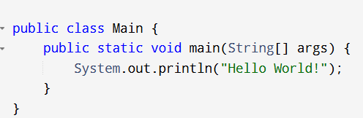

Output:

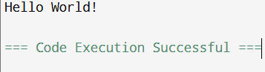

1. Java Program to take input from the user and print the sum of two numbers.

Input:

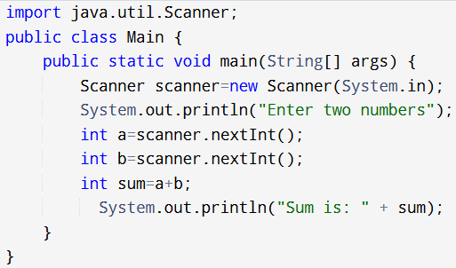

Output:

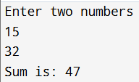

1. Create a java program to check whether a number entered by the user is even or odd.

Input:

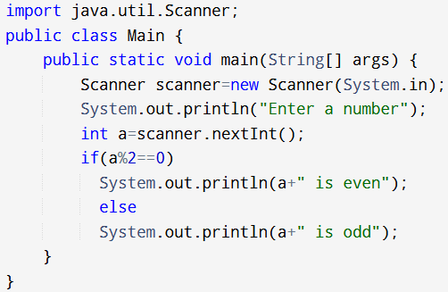

Output:

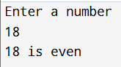

1. Create a java program to print the average and sum of 5 numbers entered by the user.

Input:

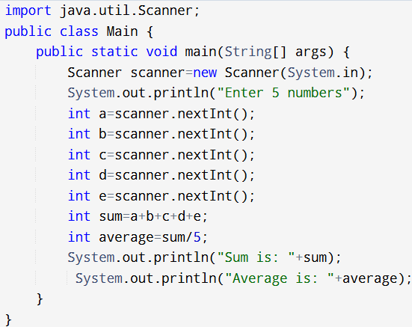

Output:

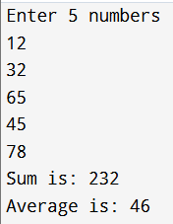

1. Program to calculate the factorial of a number. Input:

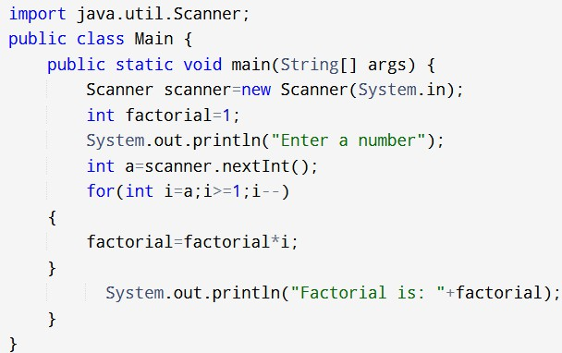

Output:

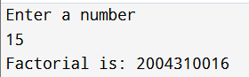

1. Program to print Fibonacci series up to n terms. Input:

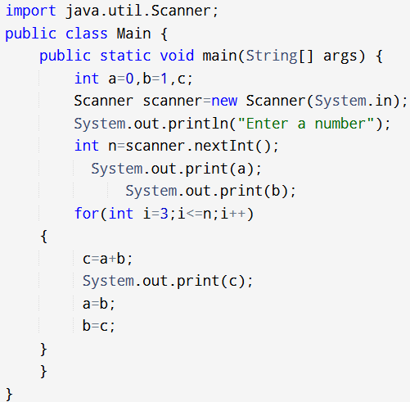

Output:

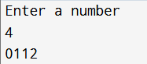

Program to reverse a number Input:

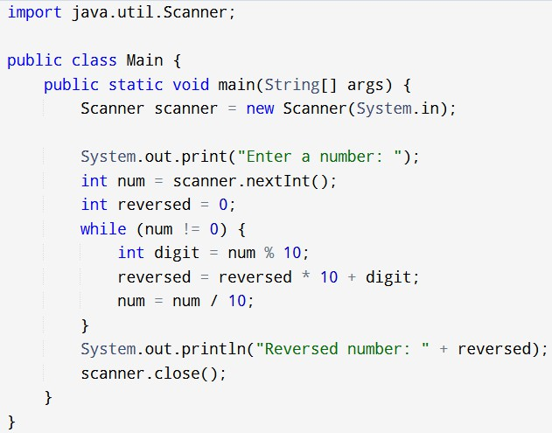

Output:

1. 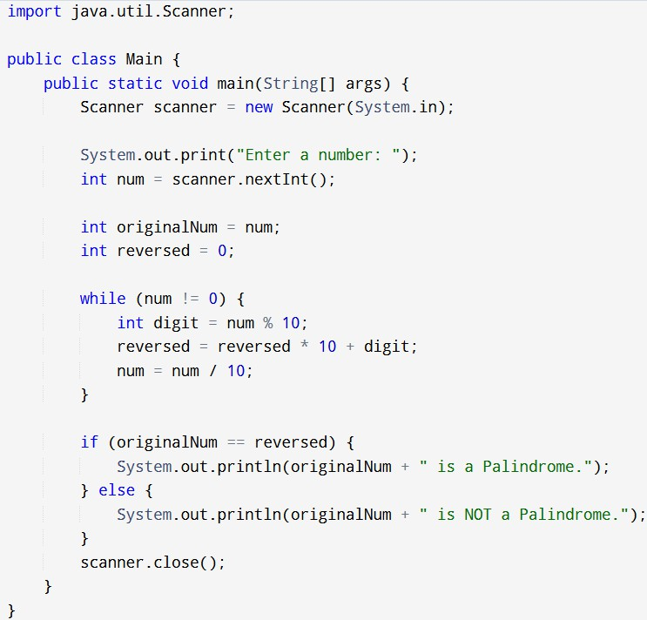Java Program to check if a number is a palindrome Input:

Output:



1. Create a java Program for a simple calculator

Input:

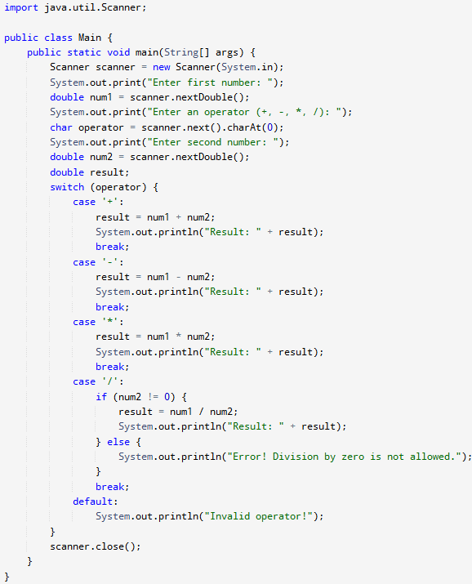

Output:

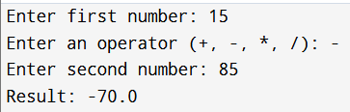

1. Create a java Program to check if a number is prime Input:

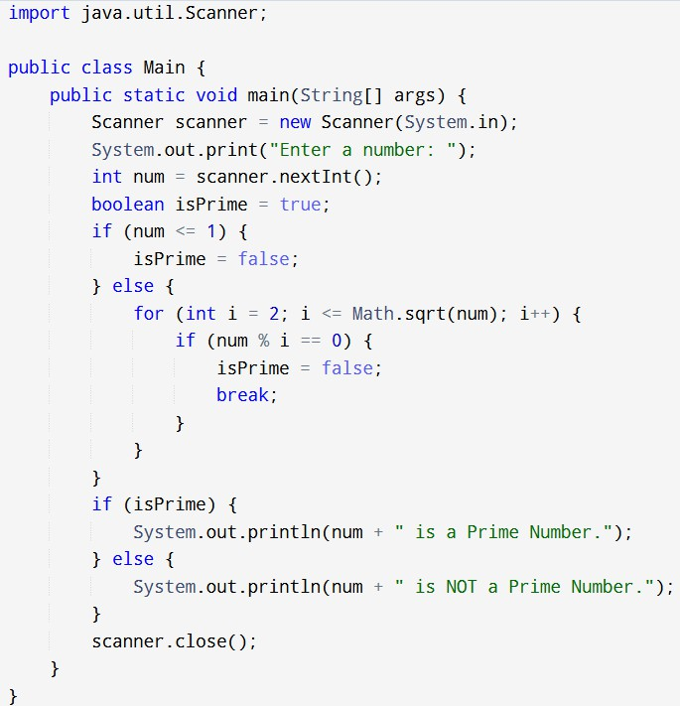

Output:

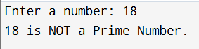

1. 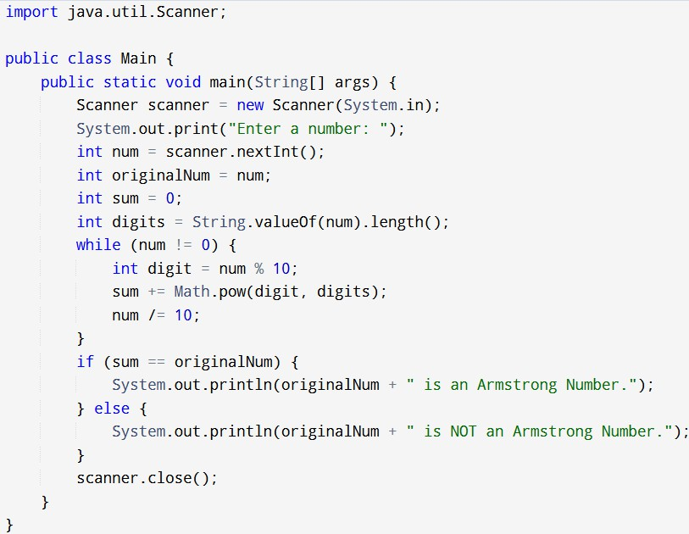Program to check if a number is an Armstrong number Input:

Output:



1. Program to Find the Largest of Three Numbers using ternary operator Input:

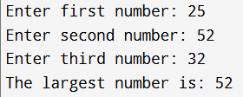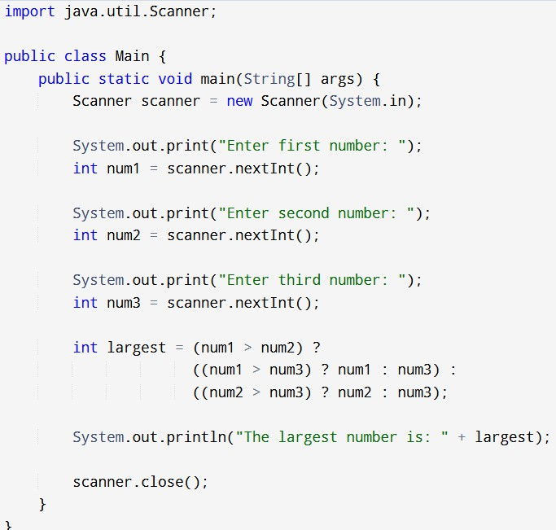

Output:

# Lab Session 3

1. 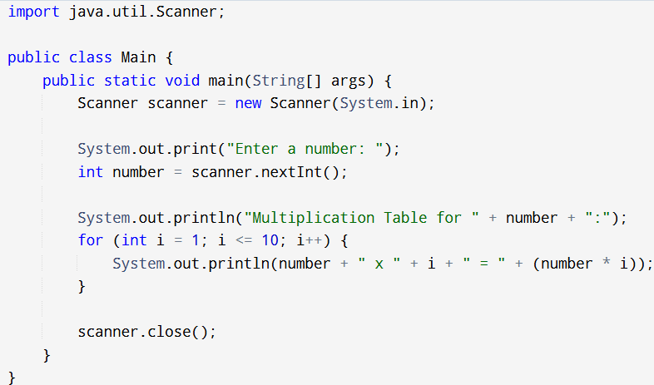Program to Print Multiplication Table Input:

Output:

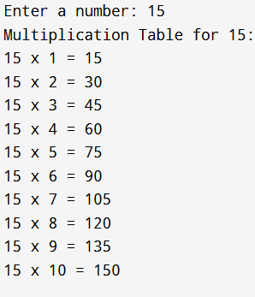

1. Java Program to Calculate Sum and Average of Array Elements Input:

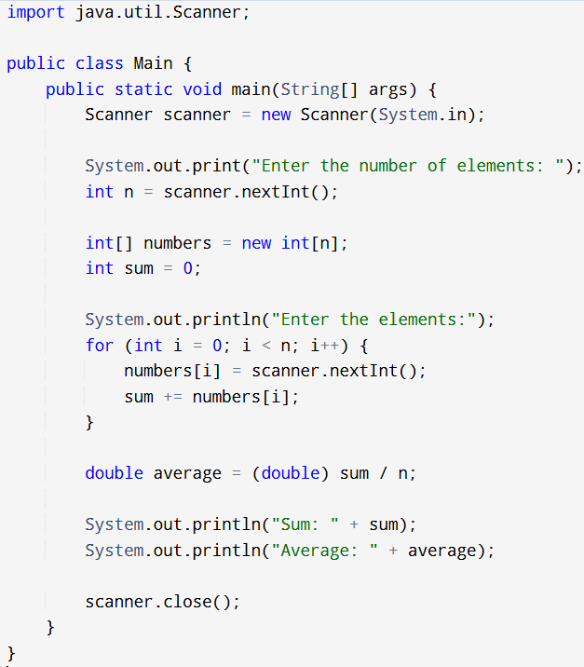

Output:

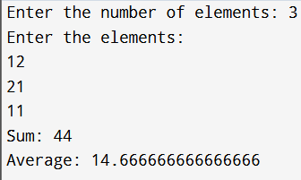

Written by Atul Vashist

1. 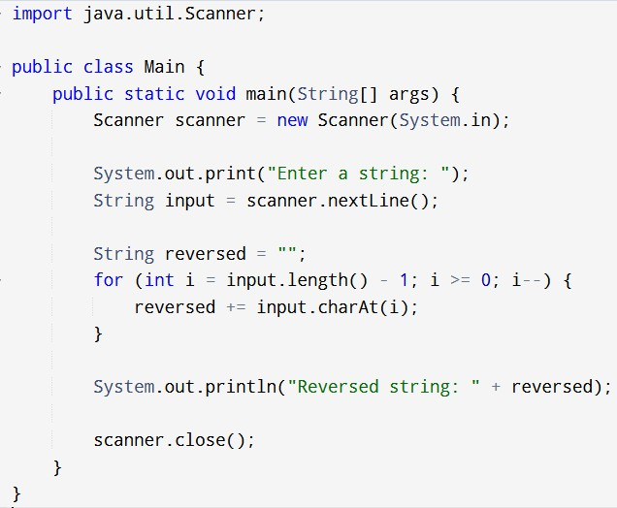Create a java Program to Reverse a String Input:

Output:



1. Create a java Program to Find Factorial of a Number Using Recursion Input:

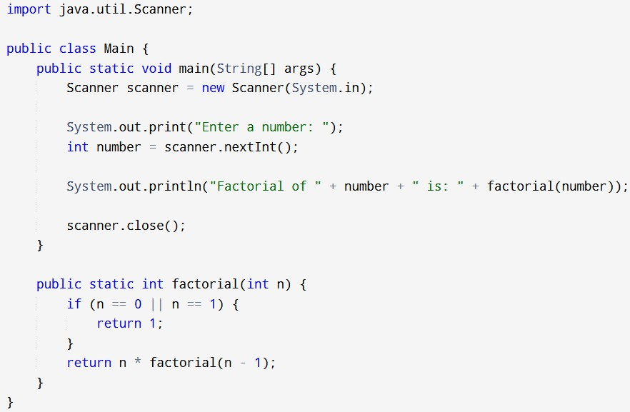

Output:

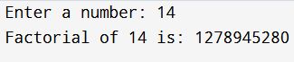

1. Program to Sort an Array in Ascending Order Input:

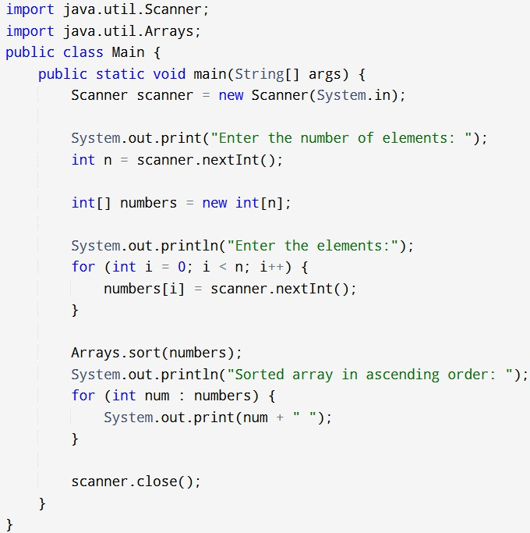

Output:

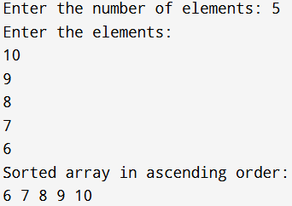

# Lab Session 4

1. 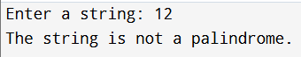Program to Check Palindrome 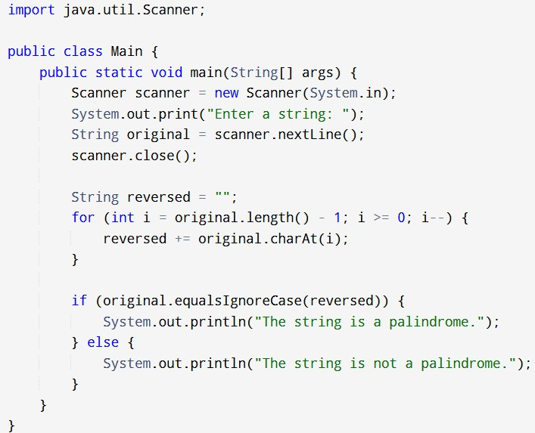

Output:

1. Java Program to Count Vowels and Consonants in a String Input:

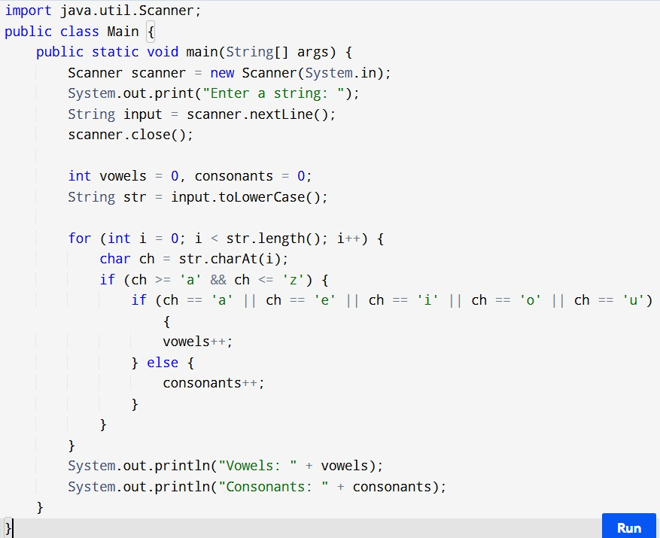

Output:

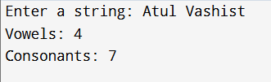

1. 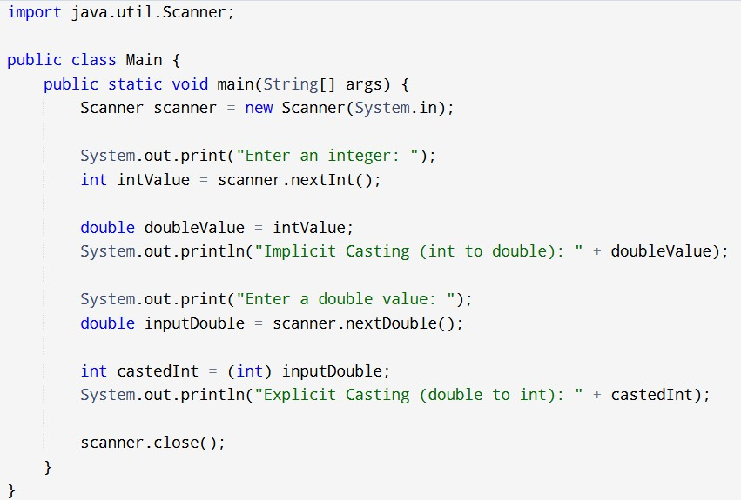Write a program to demonstrate type casting. Input:

Output:

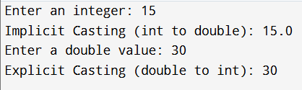

1. 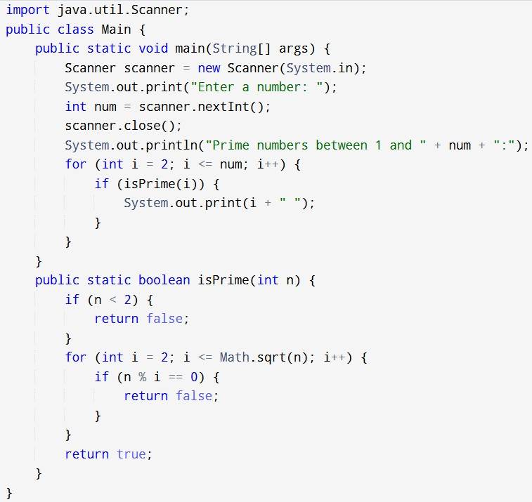Write a program to generate prime numbers between 1 & given number Input:

Output:

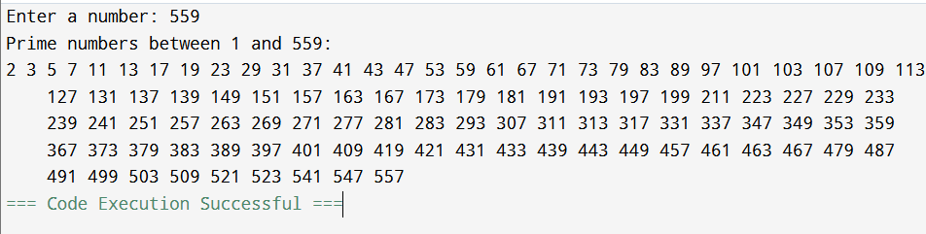

# Lab Session 5

* 1. Program to Demonstrate a Simple Class with Methods Input:

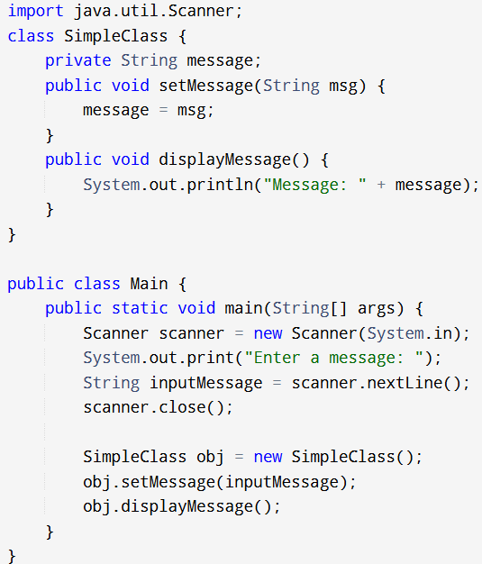

Output:

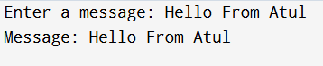

2. Java Program for Class with Parameterized

Constructor Input:

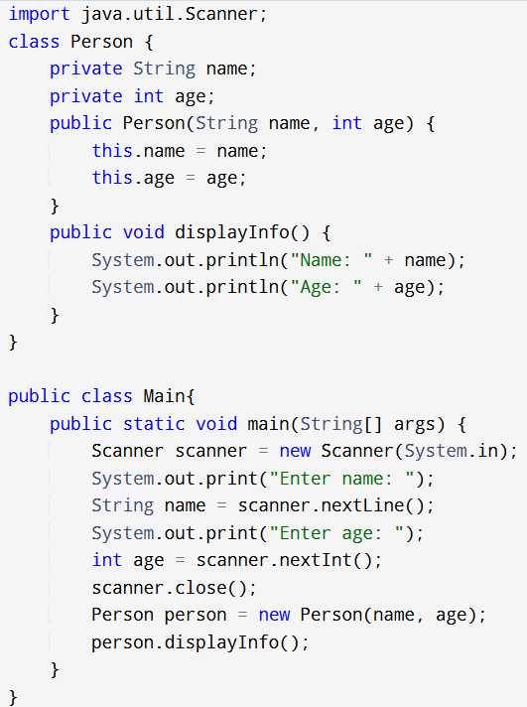

Output:

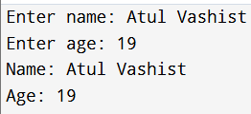

* 1. 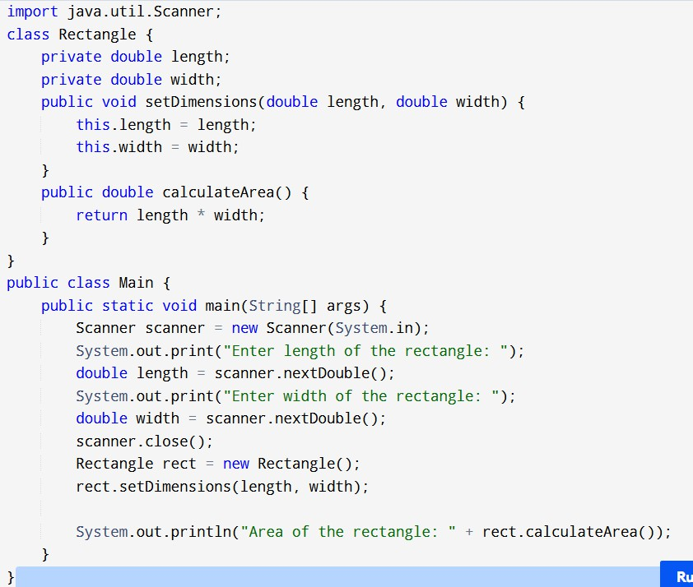Write a Program to Find the Area of a Rectangle Using Methods Input:

Output:

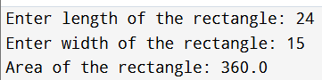

* 1. Write a Program for Bank Account Class with Deposit and Withdraw Methods

Input:

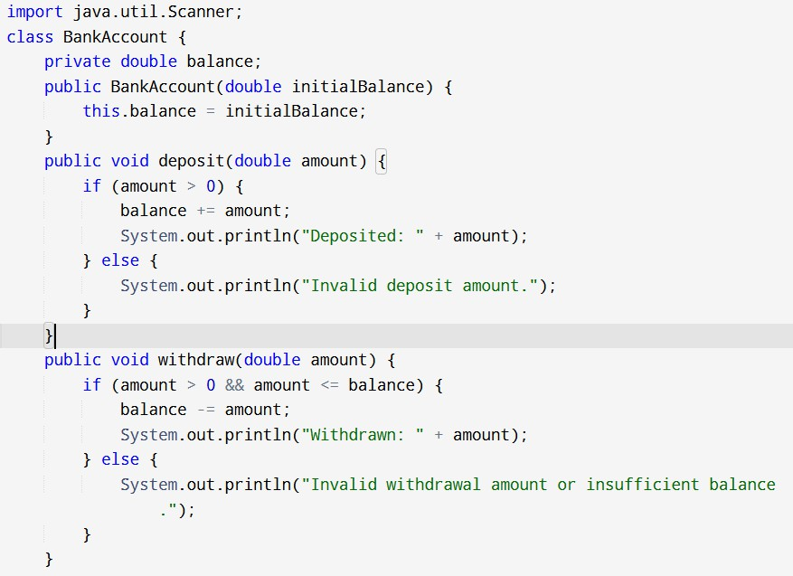

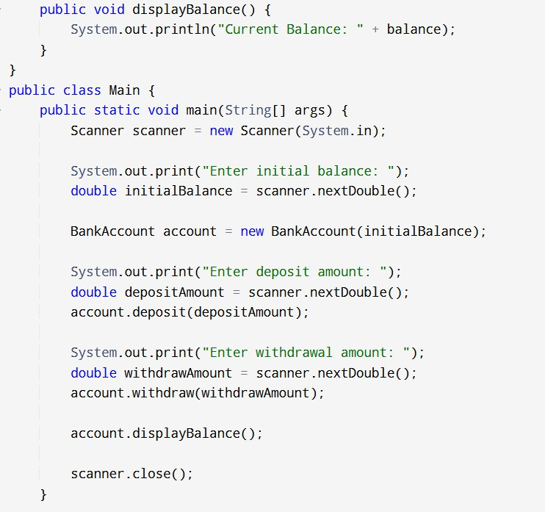

Output:

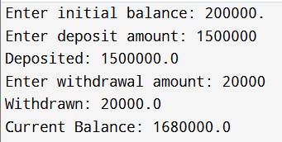

* 1. Write Program to Demonstrate Method Overloading Input:

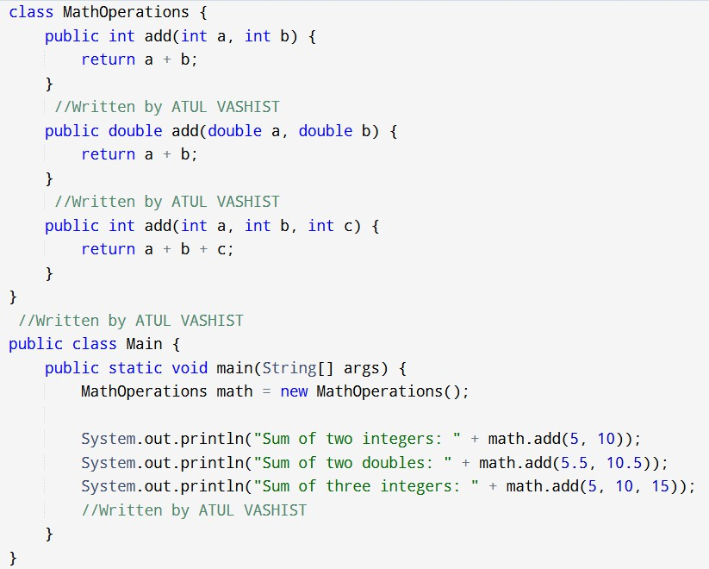

Output:

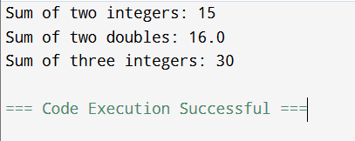

# Lab Session 6

* + 1. Program to Demonstrate Static Methods Input:

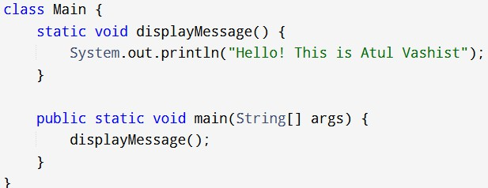

Output:

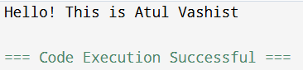

* + 1. Java Program to Demonstrate Method Overriding Input:

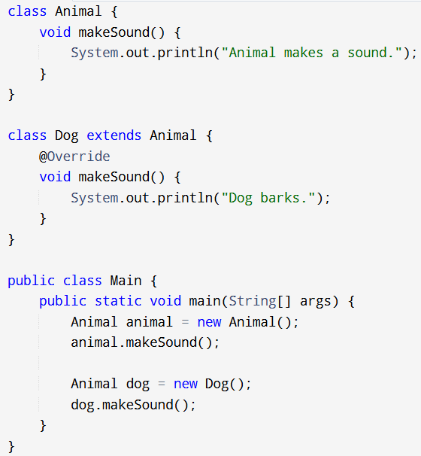

Output:

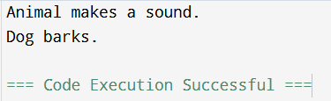

* + 1. Write a Program to Demonstrate Getters and Setters Input:

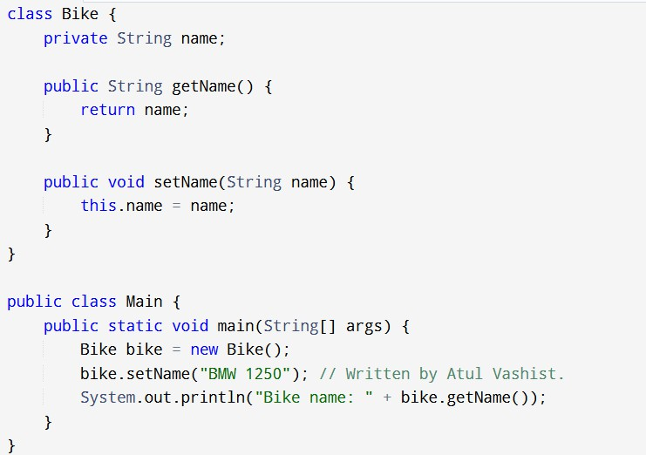

Output:

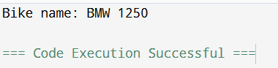

* + 1. 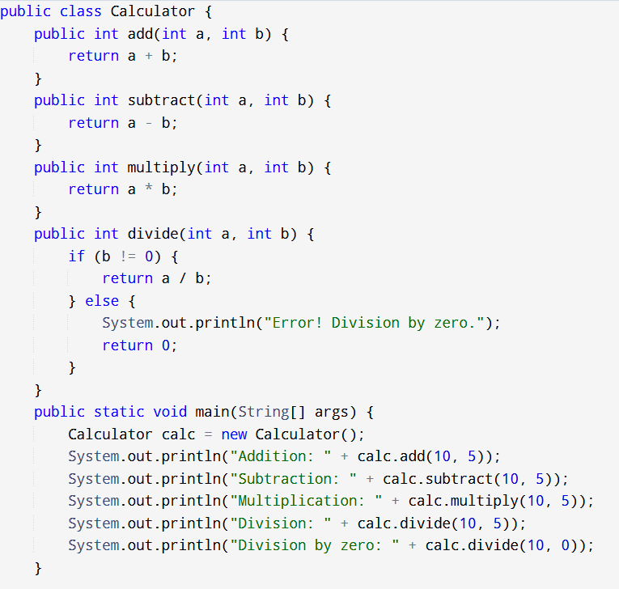Write a Program to Demonstrate a Class with Multiple Methods Input:

Output:

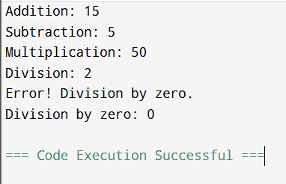

* + 1. Write a Program to Demonstrate Object Passing in Methods Input:

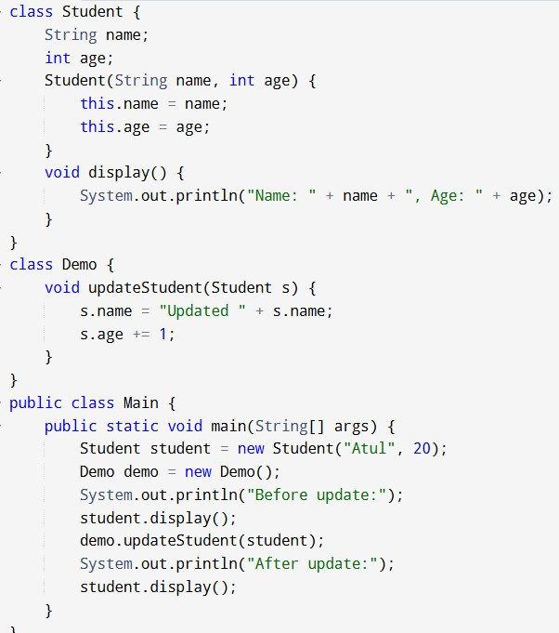

Output:

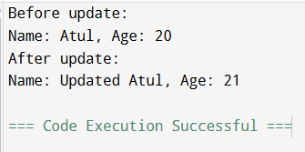

* + 1. Write a program to create a simple class to find out the area and perimeter of the rectangle using super and this keyword.

Input:

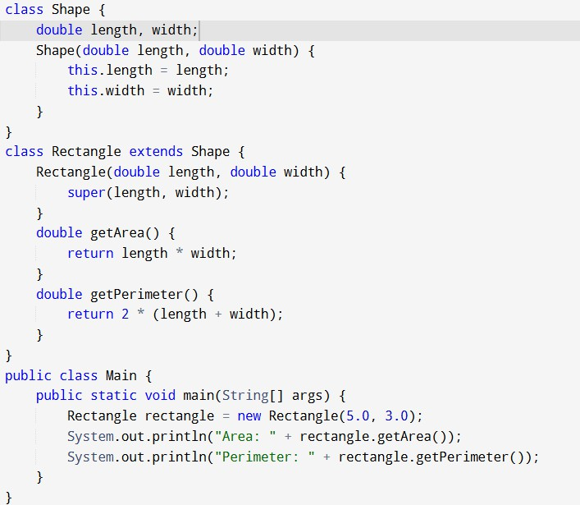

Output:

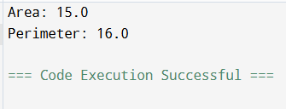

* + 1. Write a program to count the number of objects created for a class using static member function

Input:

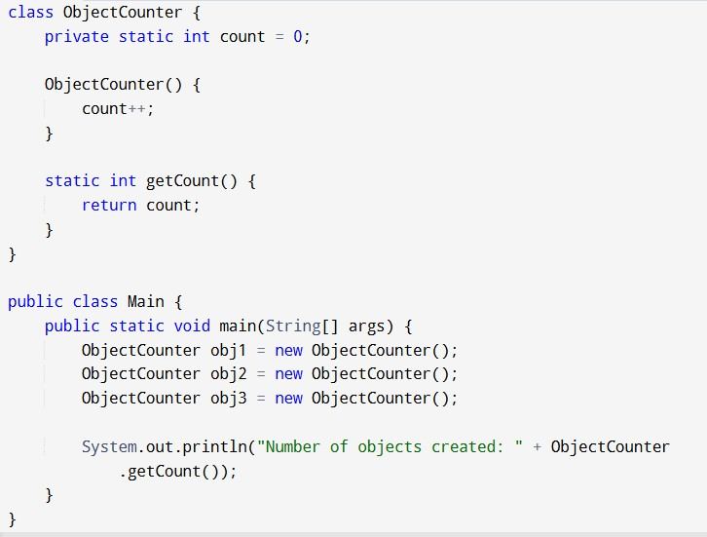

Output:

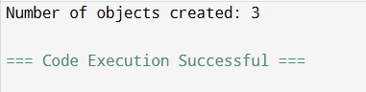

Lab Session 7

1. Write a program to design a class using abstract methods and abstract classes.

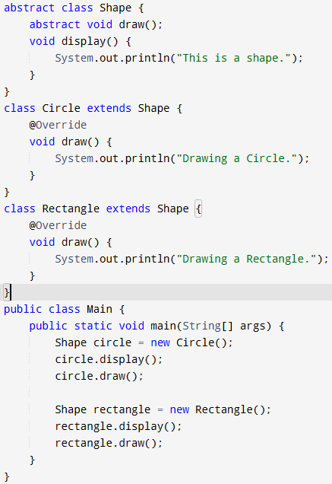Input:

Output:

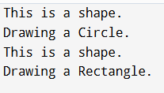

1. 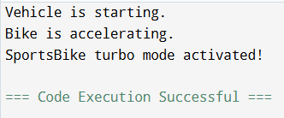Java Program to demonstrate the use of multilevel inheritance Input:

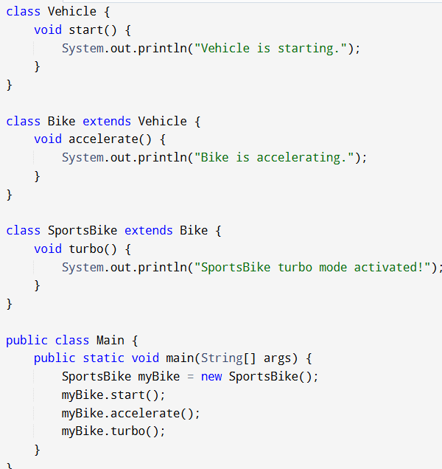

1. 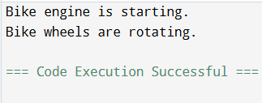Write a Program to demonstrate the use of multiple inheritance Input:

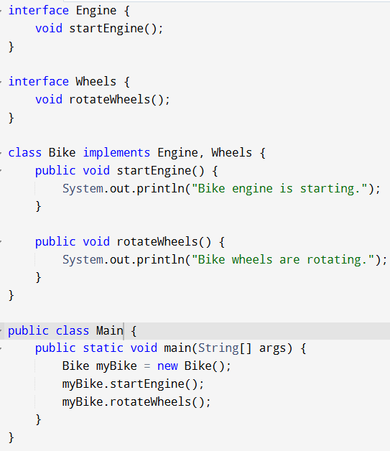

1. 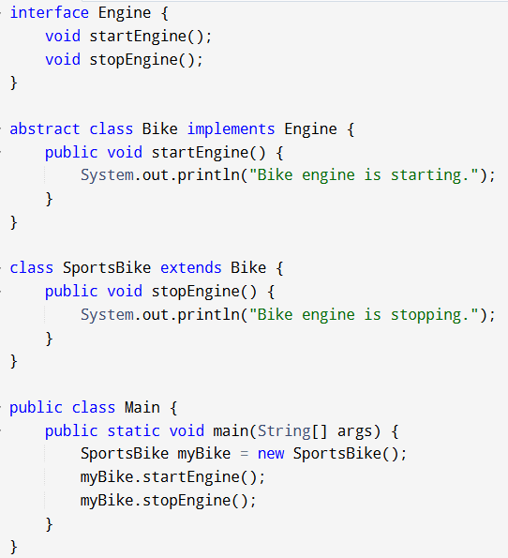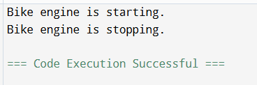Write a Program that show the partial implementation of Interface Input:
2. 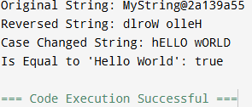Write a Program to design a string class that perform string method(Equal, Reverse the string, change case).

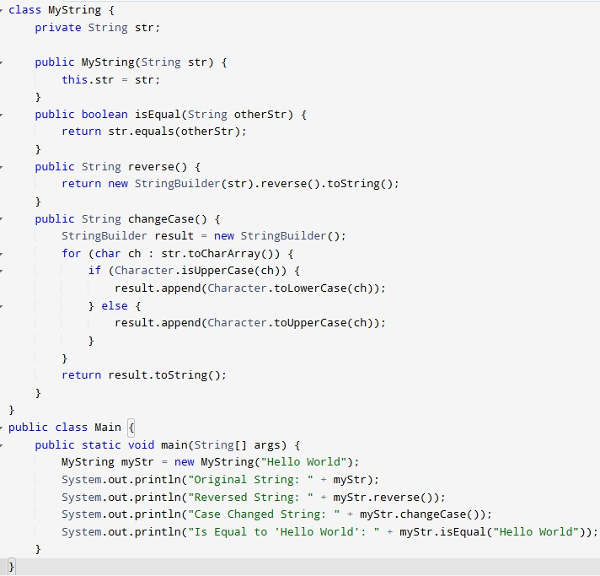Input:

1. 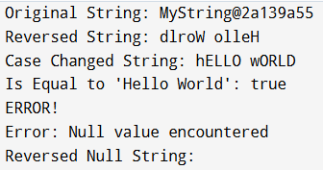Write a program to handle the exception using try and multiple catch

blocks.

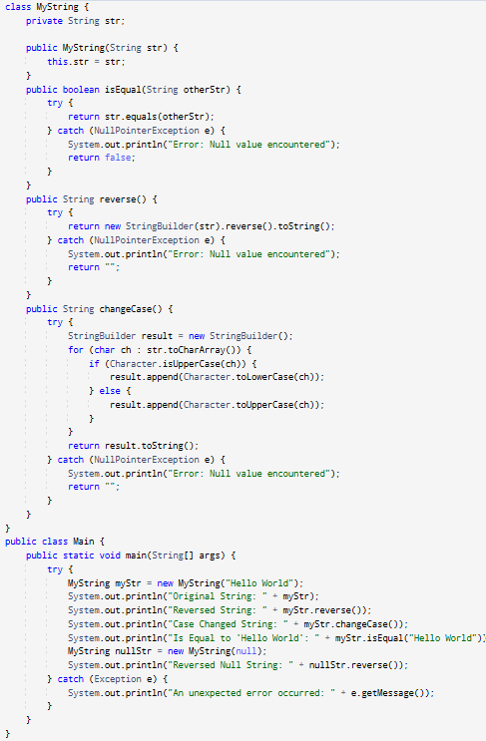Input:

1. 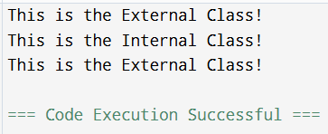Write a program to create a package that access the member of External class as well as same package

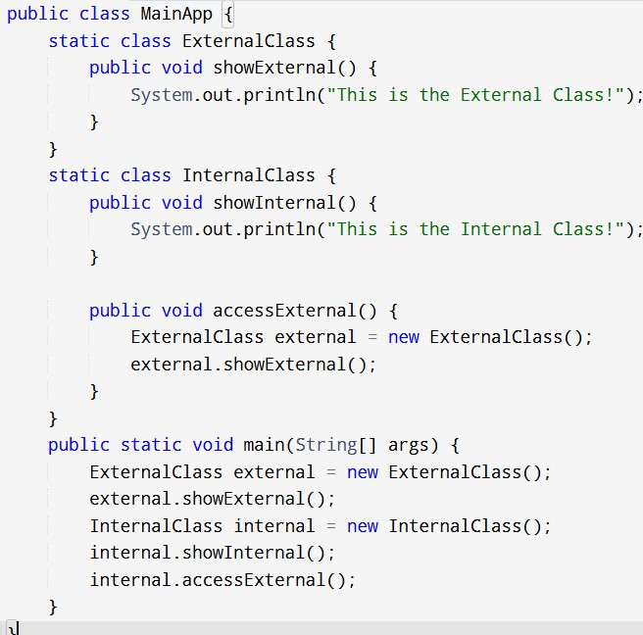Input:

1. Write a program that import the user-defined package and accesses the Member variable of classes that contained by the package.

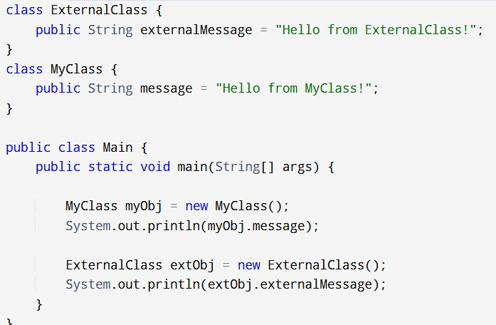Input:

Output:

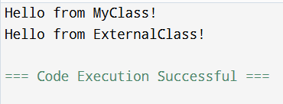

1. 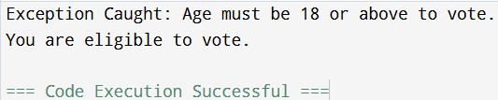Write a program to handle the user-defined exception using the throw keyword.

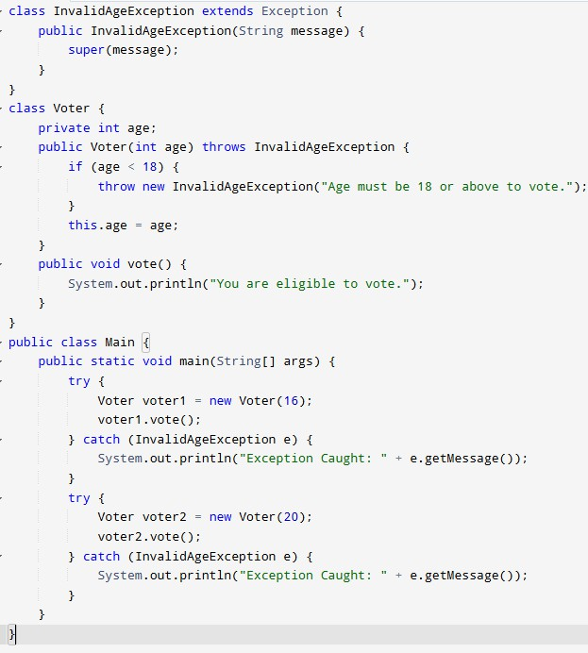Input:

**Lab Session 8**

1. Write a Java program demonstrating String methods like substring(), replace(), and split().

Input:

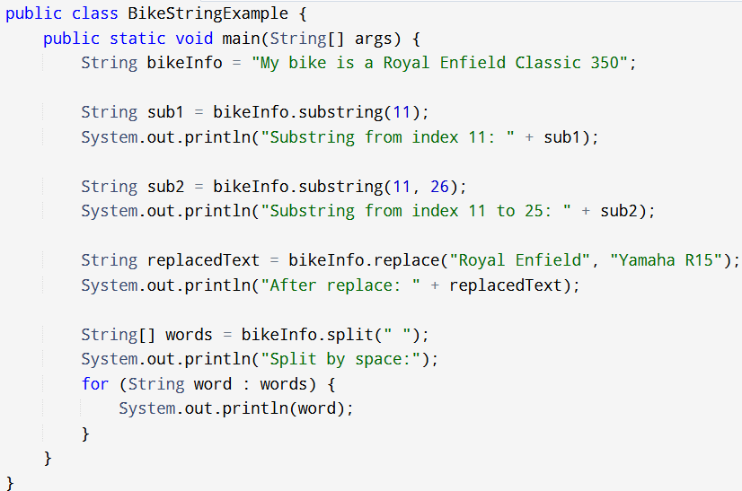

Output:

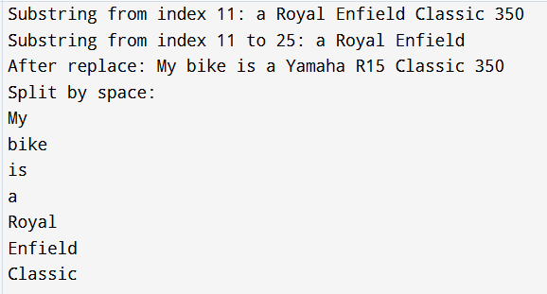

1. Create a custom exception, Age Exception, that checks if a person's age is valid (above 18). In Java

Input:

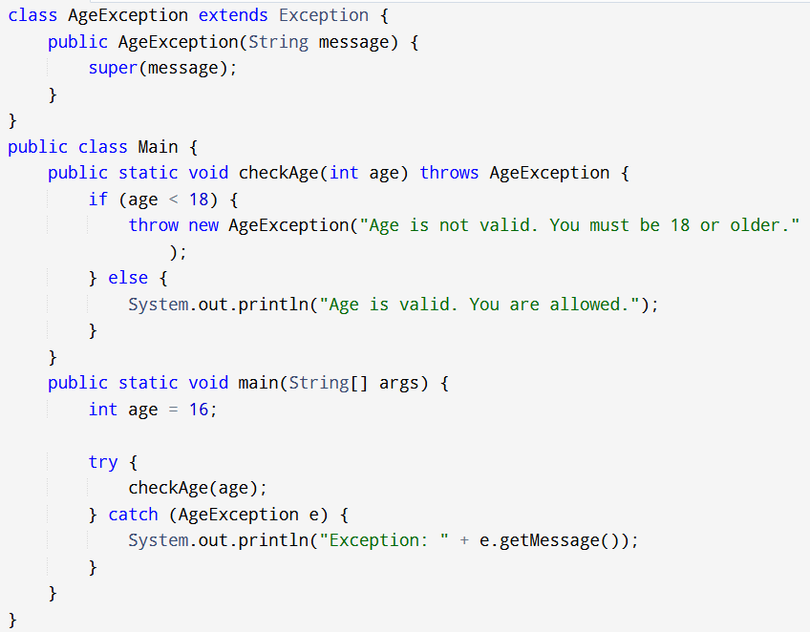

Output:

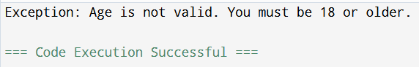

3. Create a Java program that demonstrates various string functions and string handling techniques in Java. This program includes everyday operations like: Length of a string, Concatenation, Character extraction, Substring, Searching, String comparison, C  
  
  
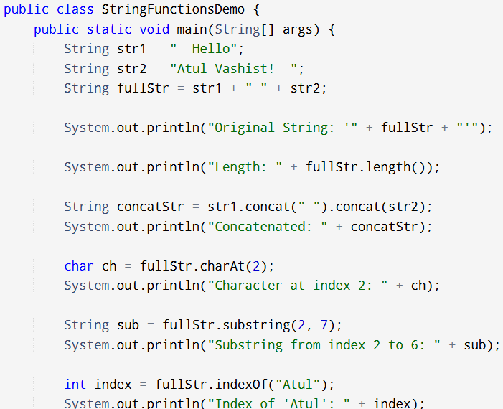hanging case, Trimming, Replacing, Splitting

Input:

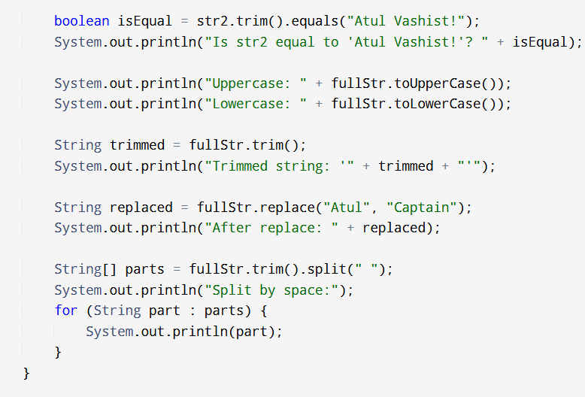

Output: 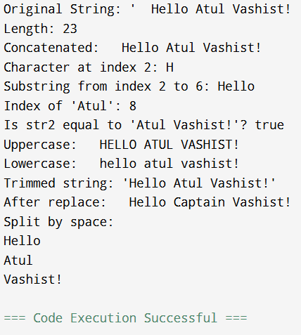

1. Write a program to create a class component that shows controls and event handling on those controls.

Input:

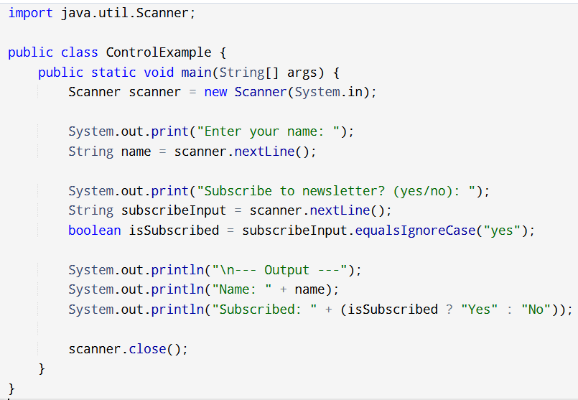

Output:

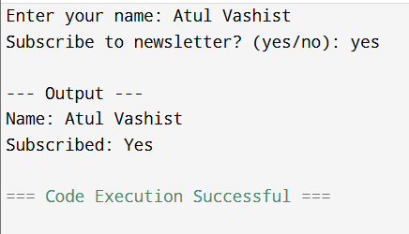

1. Write a program to draw a line, a Rectangle, an oval, and text using the graphics method.

Input:

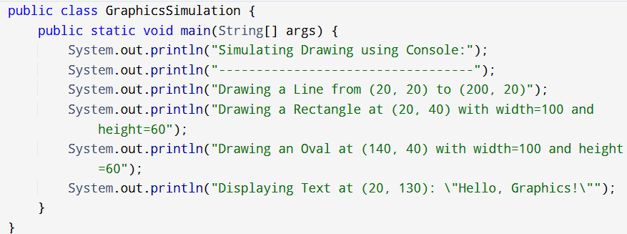

Output: 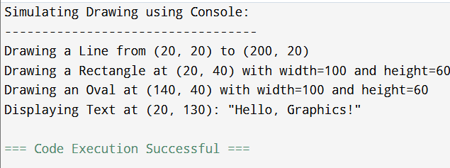

1. Write a program to create a menu using the frame.

Input:

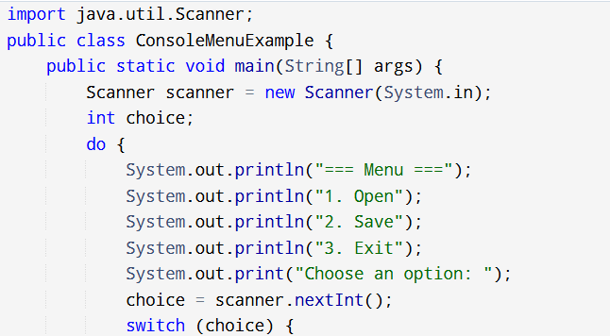

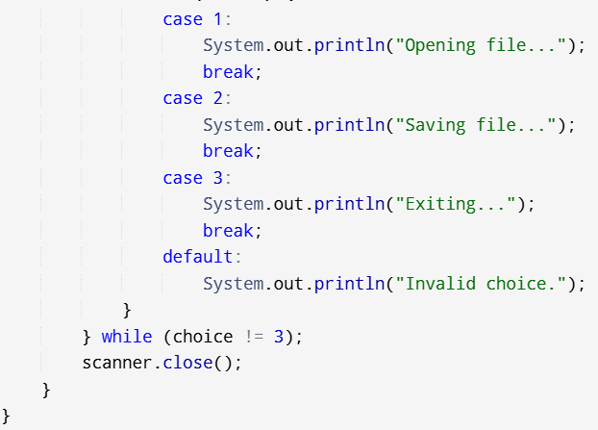

Output:

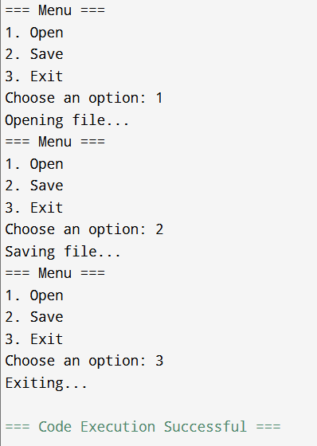

1. Write a program  to create a dialog box.

Input:

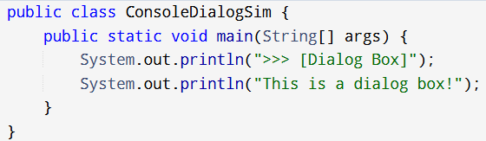

Output:

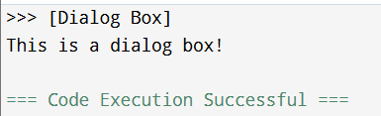

1. Write a program  to implement the flow layout and border layout.

Input:

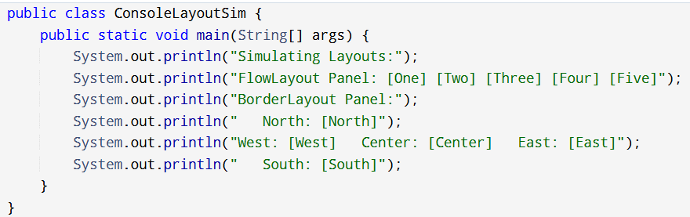

Output:

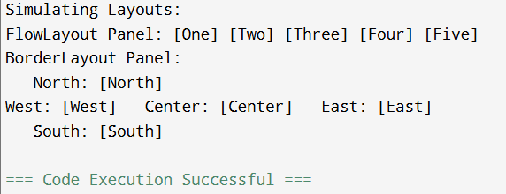

1. Write a program  to implement the gridLayout, cardLayout

Input:

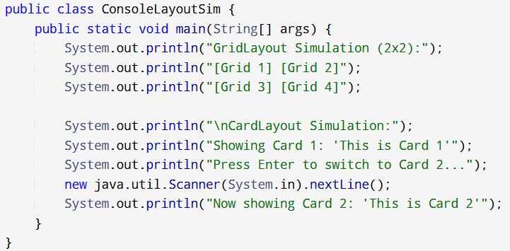

Output:

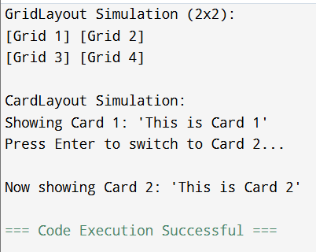

1. Write a program  to create Frame that display the student information

Input:

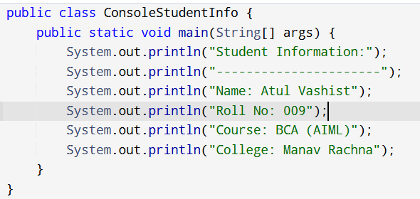

Output:

